Ansible assignment 2

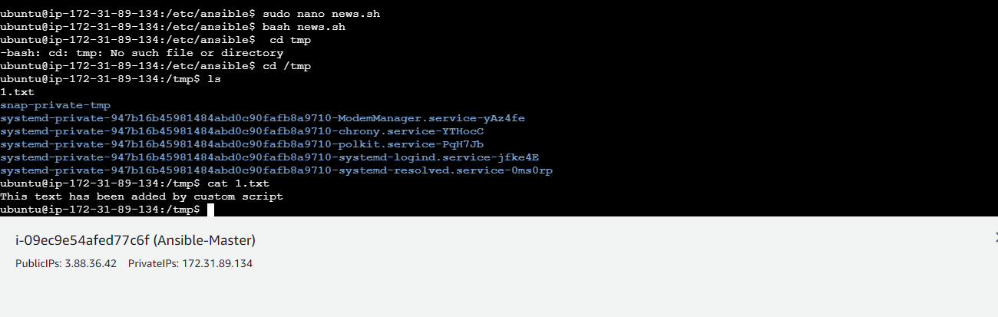

---

- name: copy.txt

hosts: all

become: true

tasks:

- name: script

script: news.sh

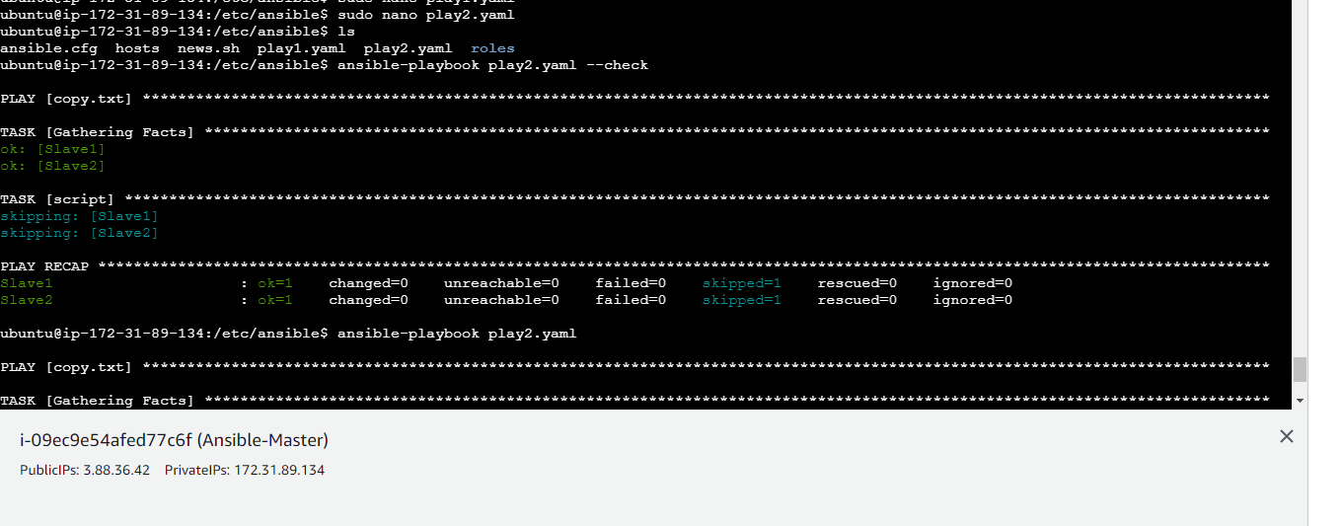

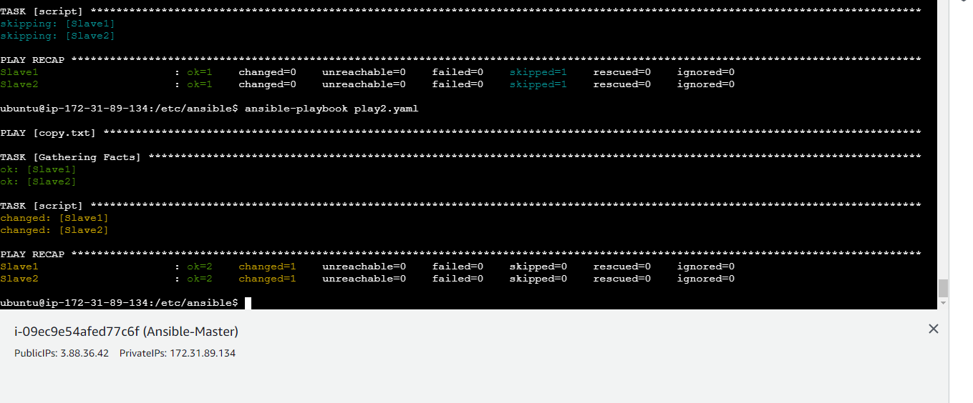

Slave 1

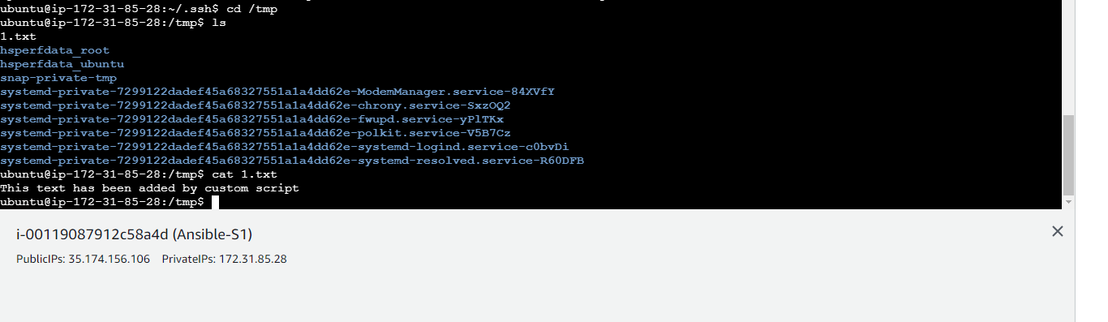

Slave 2

